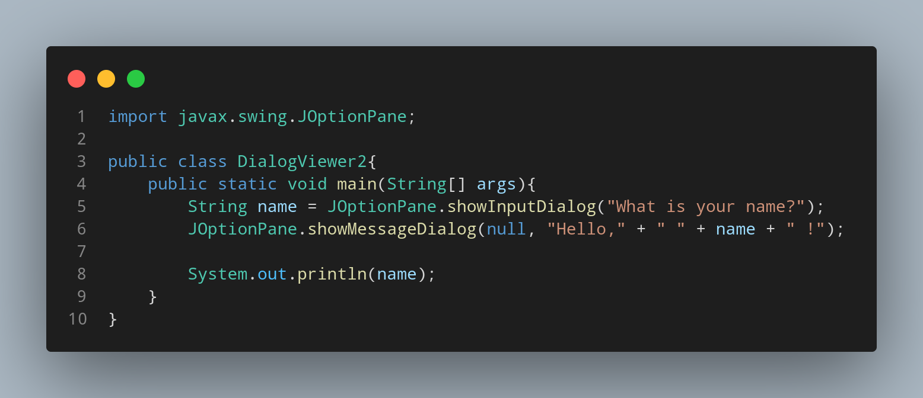

#Doc

First we import our javax.swing.JoptionPane in order to use JoptionPane.

File name DialogViewer2 is created so we create a class name DialogViewer2, inside the class we created a main function. Then we use our JoptionPane class to make a popup dialogbox where through our showInputDialog function to show our required massage in our created dialog box which ask the user to input there data and wich can take and store the data.Then return back the input data with added messsage string.

